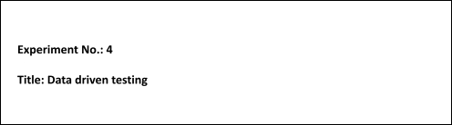

**Batch: B1 Roll No.: 16010421119 Experiment No.:4 Aim:** To perform data driven testing using excel data.

**Resources needed:** TestNG/Selenium, DataProvider.

# Theory:

**Limitations of hard-coded scripts**

A script with hard-coded data runs **only one test case**, or one set of valid test inputs, and is difficult to maintain and reuse.

**Data**-**driven testing**

It is an automation framework where test input and/or output values are read from data files. The different data files may include datapools, ODBC sources, csv files, Excel files, ADO objects, etc. The data is then loaded into variables in recorded or manually coded scripts.

Data Driven automated testing is a method in which the test data set is created in the excel sheet, and is then imported to feed to the software under test.

# What is a datapool

A datapool is a test dataset, a collection of related data records which supplies data values to the variables in a test script on run time.

# What is TestNG

TestNG is a testing framework inspired from JUnit and NUnit, but introducing some new functionalities that make it more powerful and easier to use. TestNG is an open source automated testing framework; where NG means NextGeneration. TestNG is similar to JUnit (especially JUnit 4), but it is not a JUnit extension. It is inspired by JUnit. It is designed to be better than JUnit, especially when testing integrated classes. The creator of TestNG is Cedric Beust.

# Data Provider

Data Provider is nothing but a set of libraries that is used to communicate with data source. Eg: SQL data provider for SQL, Oracle data provider for Oracle, OLE DBdata provider for access, excel or mysql.

# Procedure:

**Step 1: Creation of a Datapool:**

* Create an excel workbook with dataset and "save as" your workbook as "Excel 97-2003 workbook".
* 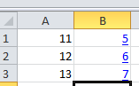Example: Input.xls

# Step 2: Adding the Datapool to Eclipse

1. Download jxl-2.6.12.jar form Link : <http://www.java2s.com/Code/Jar/j/Downloadjxl2612jar.htm> and Extract. **OR take form 172.17.1.11/ STQA WriteUp folder**
2. Build path to Eclipse IDE

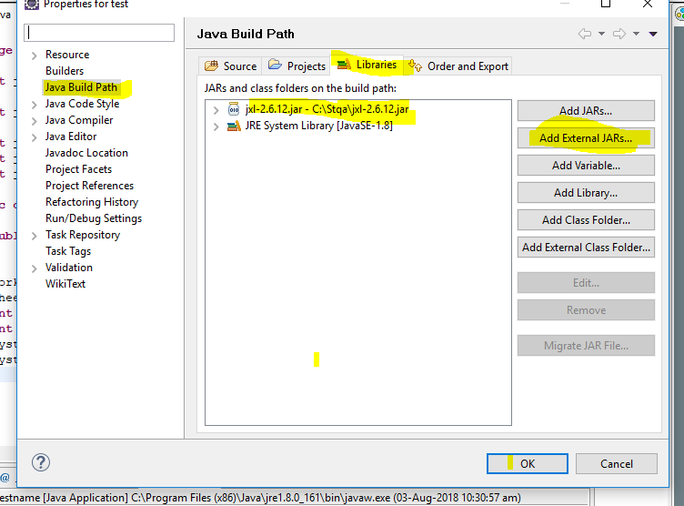

1. Write the following code in Eclipse to access Input.xls and **observe the output**

package test; import java.io.*; import

java.io.IOException; import jxl.Sheet; import jxl.Workbook; import

jxl.read.biff.BiffException; public class class2 {

public static void main(String[] args) throws BiffException, IOException

{

File f =new File("C:/Stqa/Input.xls"); Workbook wb=Workbook.getWorkbook(f); Sheet s= wb.getSheet("Sheet1");

int rows=s.getRows(); int columns

=s.getColumns(); System.out.println(rows); System.out.print(columns);

}

}

1. 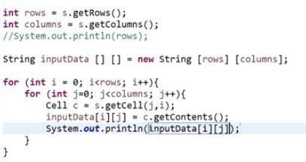Add the code and **observe the outpu**
2. Remove the main method. Add object and DataProvider

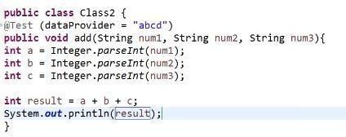

6. Write test case for addition of three numbers [data from Input.xls] using DataProvider

# OR

**Using Selenium**

Follow the steps as mentioned below to create a basic Data Driven framework, which will be used to automate the ["Student Registration Form".](https://demoqa.com/automation-practice-form)

* Create three [New Packages](https://www.toolsqa.com/selenium-webdriver/configure-selenium-webdriver-with-eclipse/) in your Project for testCases, testData, and utilities.
* Under the testData package, put your Excel Sheet that has test data. Using this, we separate the test data from the testCases.
* Under the utilities, [create a New Class](https://www.toolsqa.com/selenium-webdriver/configure-selenium-webdriver-with-eclipse/#package) and name it "ExcelUtils". It will contain all functions related to Excel used for reading and writing.
* Under the utilities package, create another class "Constants". It will contain the constant values across the framework like testdata file path, URL of the application, etc.
* Under the testCases package, we will create the test files that contain the Selenium code for interacting with web elements. (For Example, RegisterStudentTest.java)

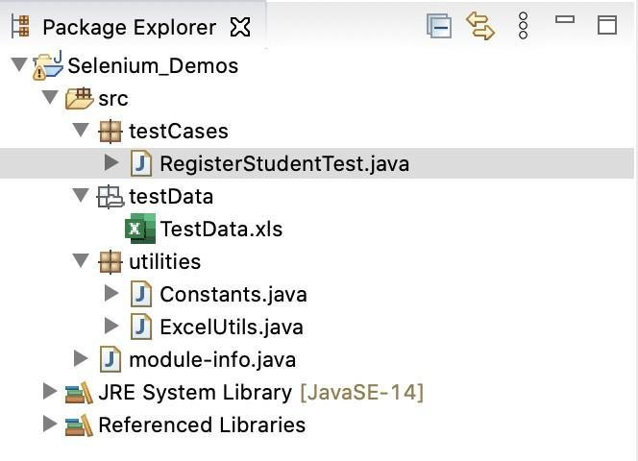

# Results: (Document printout as per the format)

1. Create different dataset in Sheet1, Sheet2…of a workbook.
2. Write test cases for Sheet1, Sheet2…datasets.

**Create and populate input.xls Sheet 1**

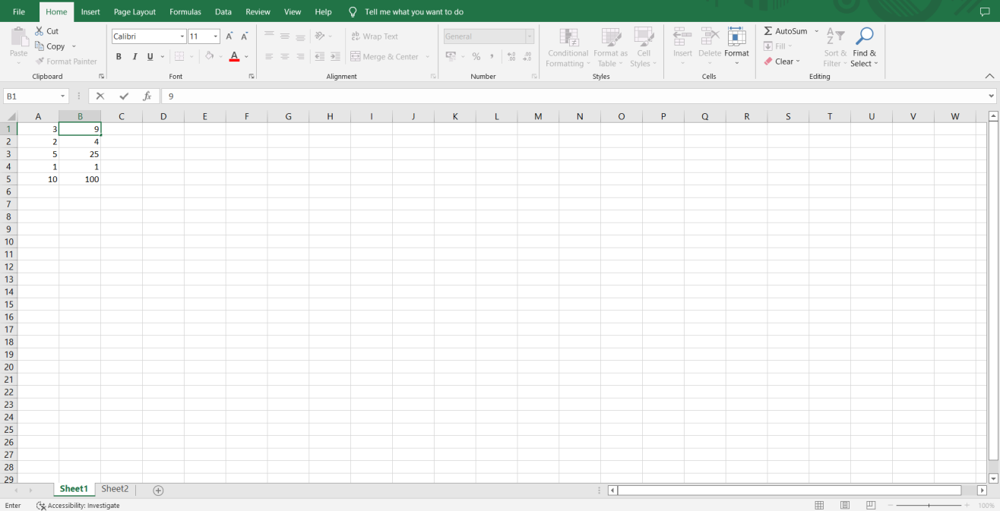

**Sheet2**

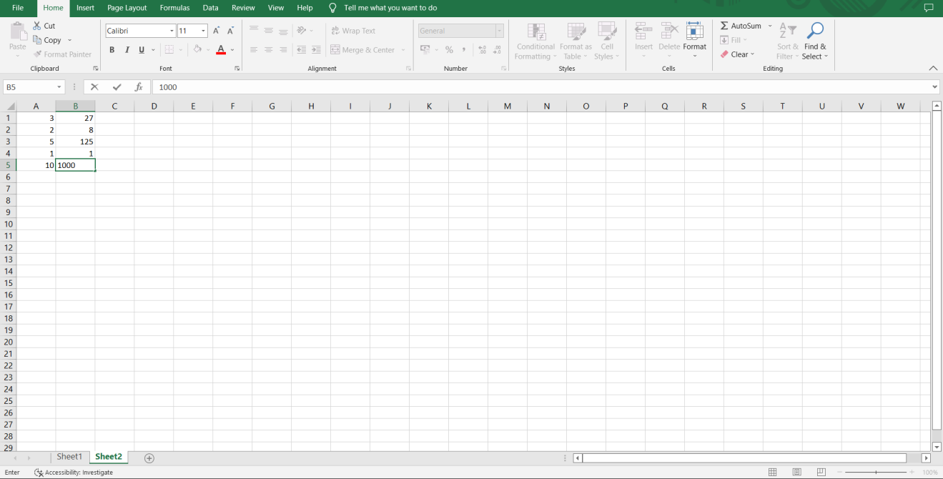

**Launch eclipse**

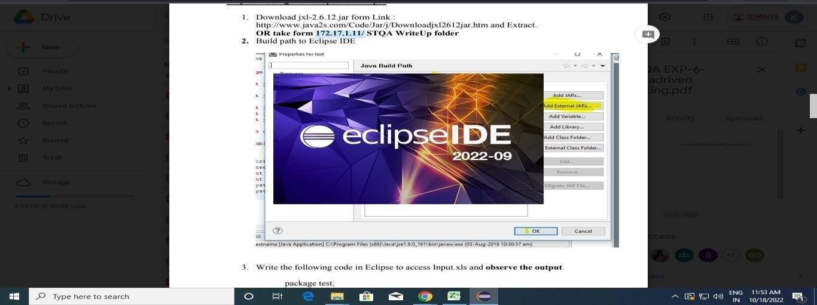

**Configure build path**

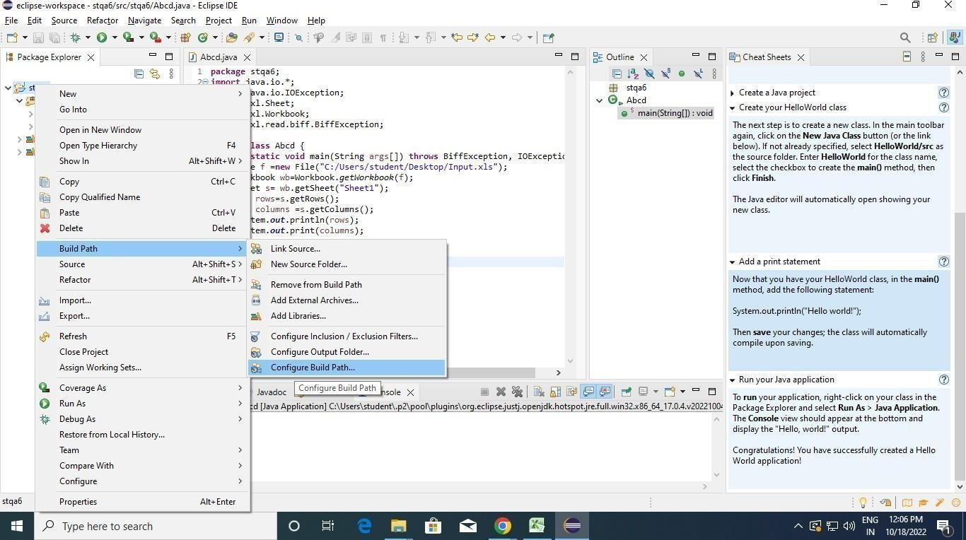

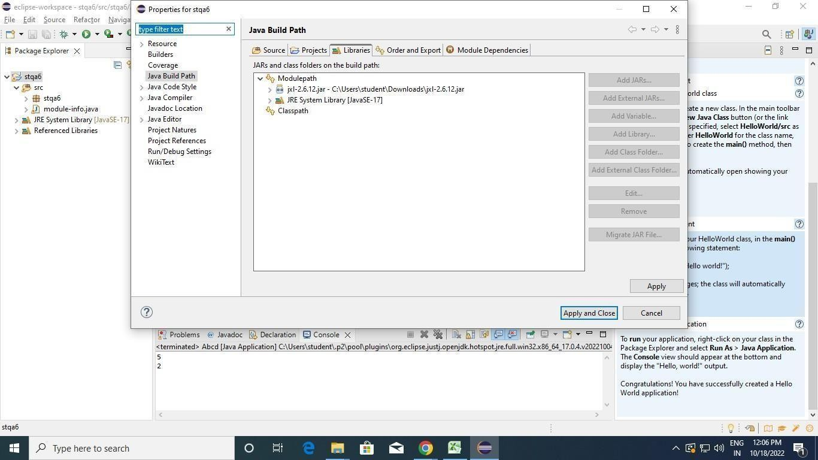

**Output:**

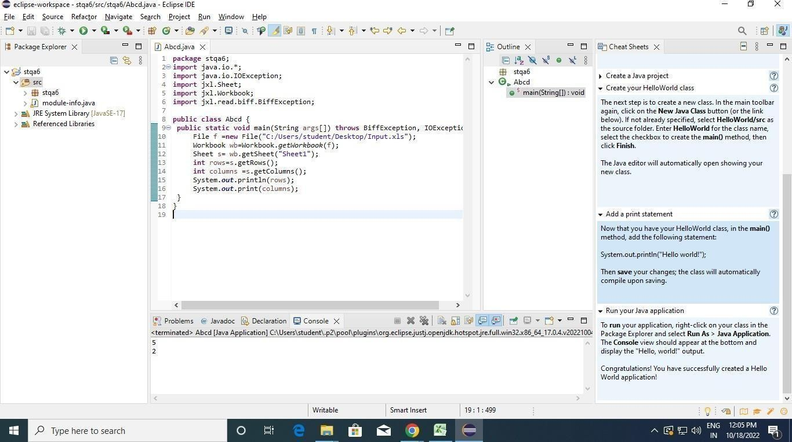

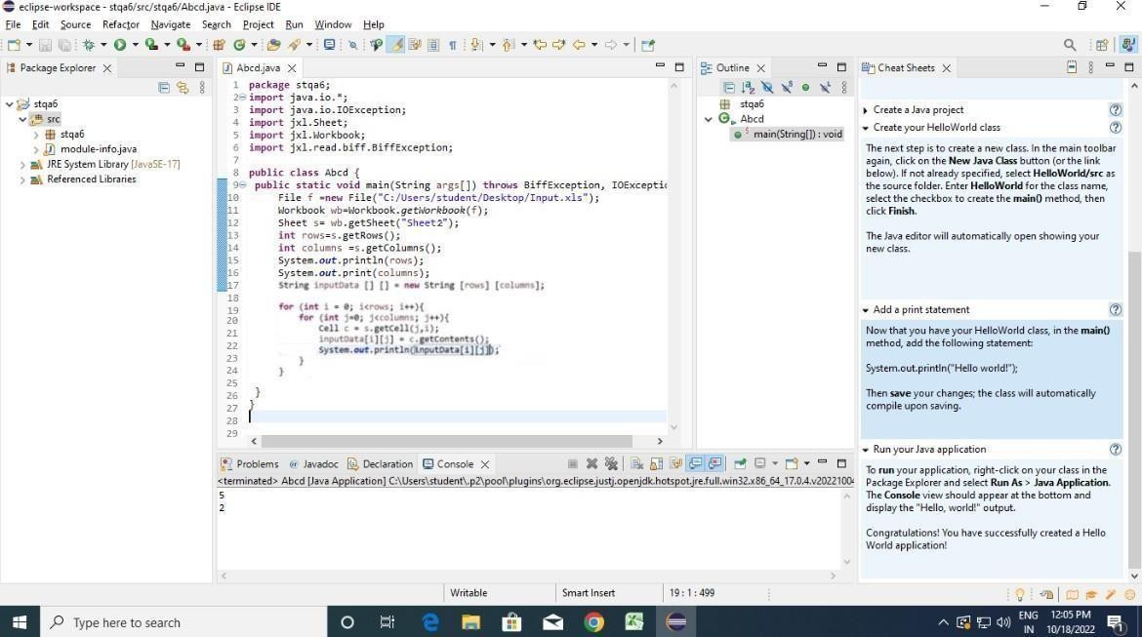

Questions:

* 1. **Write note on keyword driven testing.**

**Ans:** Keyword-Driven Testing

Keyword-driven testing is an automation framework where test cases are created using predefined keywords that represent specific actions (e.g., "Click," "Enter Text," "Verify"). This method allows testers to design tests without needing to write code, making it more accessible and easy to maintain.

How It Works:

* + - Keywords: Each keyword corresponds to an action or function.
    - Test Scripts: Test cases are written using these keywords, often in a table format.
    - Execution: The framework interprets the keywords and executes the corresponding actions on the application.

Benefits:

* + - Reusability: Keywords can be reused across multiple test cases.
    - Ease of Use: Non-developers can create and manage tests.
    - Scalability: Easily scalable for large test suites.

Example: A login test might use keywords like "Open Browser," "Enter Text," and "Click" to perform the login operation without writing any code.



# Outcomes:

**CO3:**Apply recent automation tools for testing software

# Conclusion: (Conclusion to be based on outcomes)

Data-driven testing was implemented using Eclipse IDE and MS Excel in Java. Test data was stored in Excel, and test cases were written in Java. This approach enabled efficient testing with multiple data sets, with outputs accurately recorded, ensuring thorough and reliable test coverage.

# Grade: AA / AB / BB / BC / CC / CD /DD Signature of faculty in-charge with date

**Reference Websites:**

1. [TestNG Tutorial](https://www.tutorialspoint.com/testng/)

https://[www.tutorialspoint.com/testng](http://www.tutorialspoint.com/testng)

1. TestNG framework: data driven testing using Excel. <https://www.youtube.com/watch?v=ZkVdFIozu_E>
2. DataProvider in TestNG <https://www.youtube.com/watch?v=nECnf0wMXqk>
3. Data Driven testing <https://www.softwaretestinghelp.com/testcomplete-tutorial-2/>
4. <https://www.youtube.com/watch?v=2bPjc_LXnAg>